Case Study: Flat rate shipping not showing based on specific product

Client Name: Fred Edmunds
Client website URL: https://www.kmtparts.com/

Overview
The issue you're facing with flat rate shipping not showing up based on a specific product in your WooCommerce store indicates a discrepancy between your shipping settings and the product's configuration.

What was the challenge to troubleshoot the issue
Flat rate shipping isn't being calculated for a specific product in your WooCommerce store when it should be. This suggests that there might be a misconfiguration or conflict within your settings.

1. Check Product Shipping Class:
- Each product in WooCommerce can be assigned a shipping class. Make sure that the specific product has the correct shipping class assigned to it.
- Go to the product's edit page, and in the "Shipping" tab, check the shipping class assigned to the product. If needed, assign the correct shipping class.

2. Verify Shipping Zone Configuration:
- Go to your WordPress admin dashboard.
- Navigate to WooCommerce > Settings > Shipping.
- Within each shipping zone, ensure that the flat rate shipping method is enabled and configured as expected.
- Check that the shipping class associated with the product is allowed by the flat rate shipping method.

3. Product-Specific Shipping Methods:
- Some plugins or custom code might allow you to set up product-specific shipping methods. Check if there's any plugin or code affecting the shipping methods based on specific products.

4. Product Variations:
- If the product in question has variations, make sure that the shipping class is assigned correctly to each variation.
5. Flat Rate is Restricted:
- Some plugins or settings might restrict the use of flat rate shipping based on certain conditions, such as minimum cart total, specific product types, or specific shipping classes.
- Review your WooCommerce settings to ensure there are no restrictions in place.

What were the solutions to fix this issue

Product Settings: The product might not be configured with the correct shipping class or zone, preventing the flat rate from being applied.
Woocommerce -> settings → shipping → Shipping classes
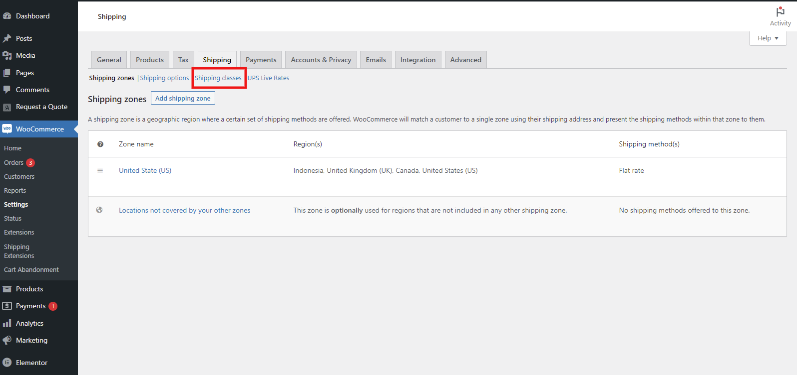

Now check your shipping class or add new class:
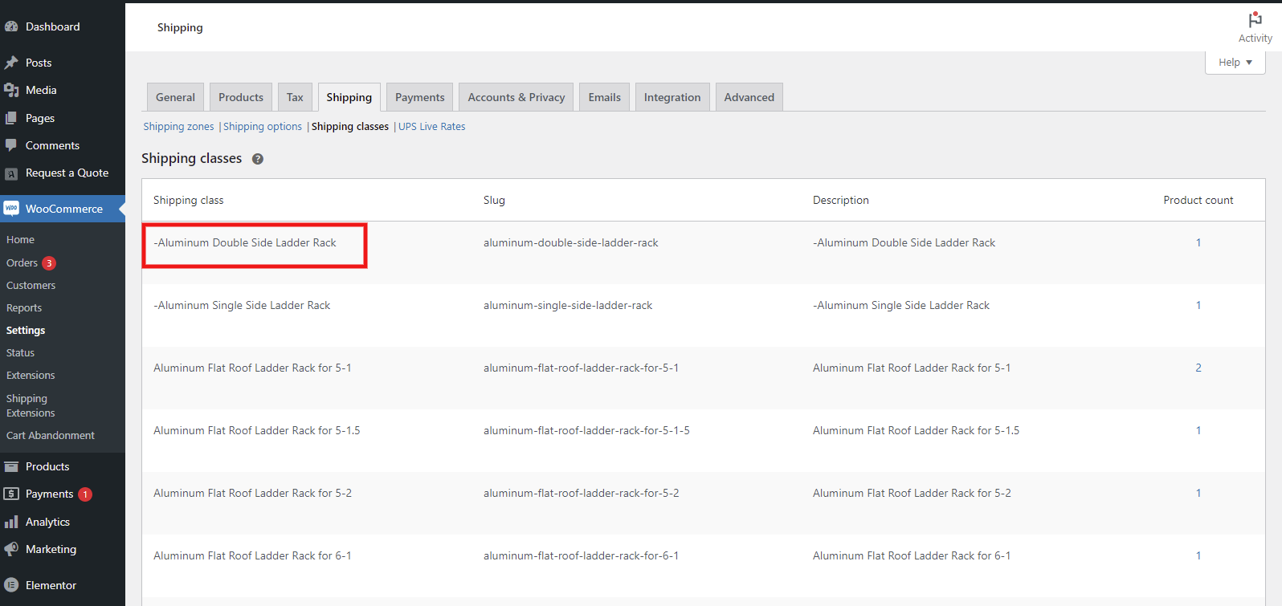

Shipping Classes: The product's shipping class might not be associated with the flat rate shipping method, causing the rate to not apply to the product.

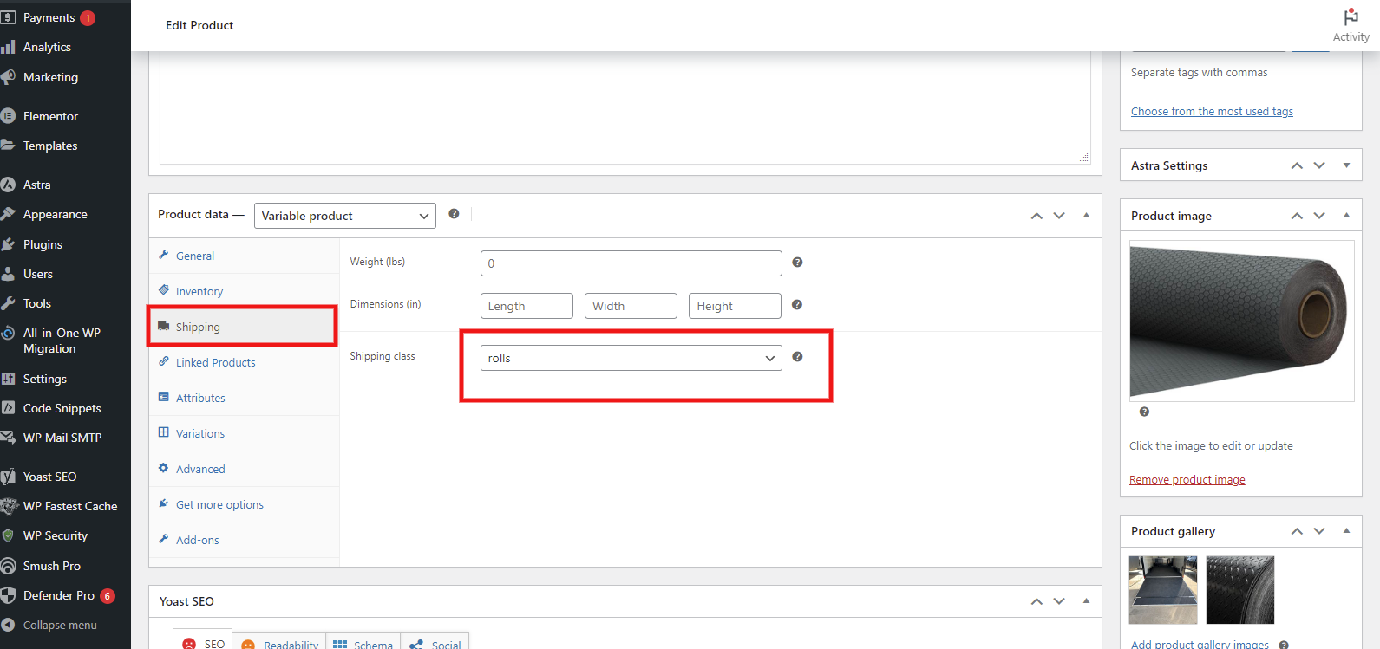

Shipping Zones: The product's shipping zone might not match the customer's location, resulting in the flat rate not being visible.
Woocommerce -> settings → shipping → Shipping zones
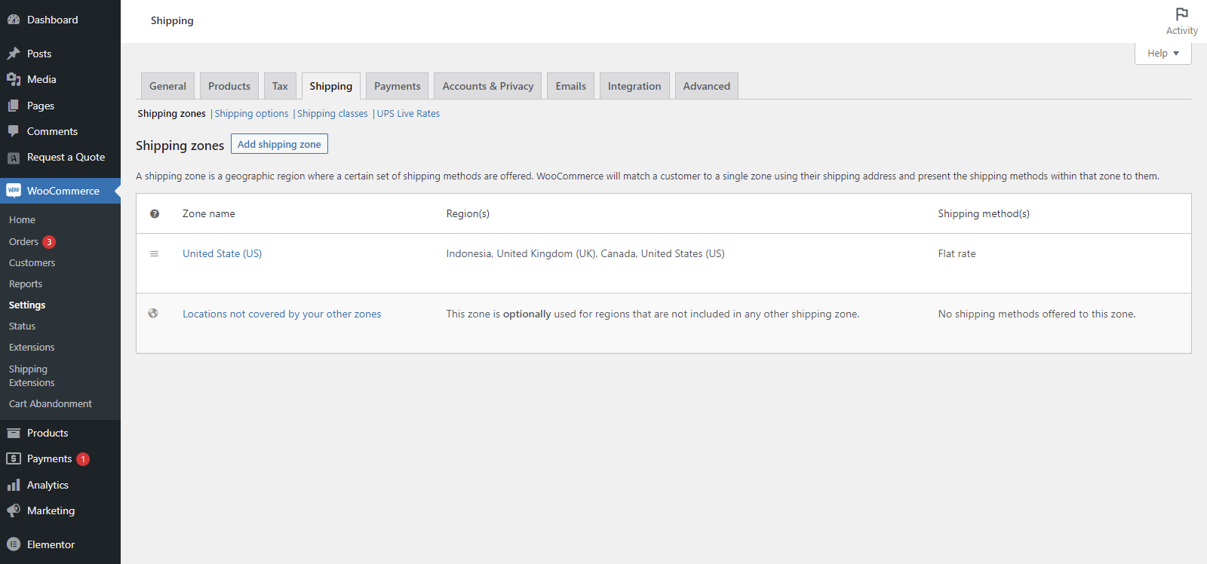
Flat Rate Method: The flat rate shipping method might not be properly configured, causing it to not apply to certain products.
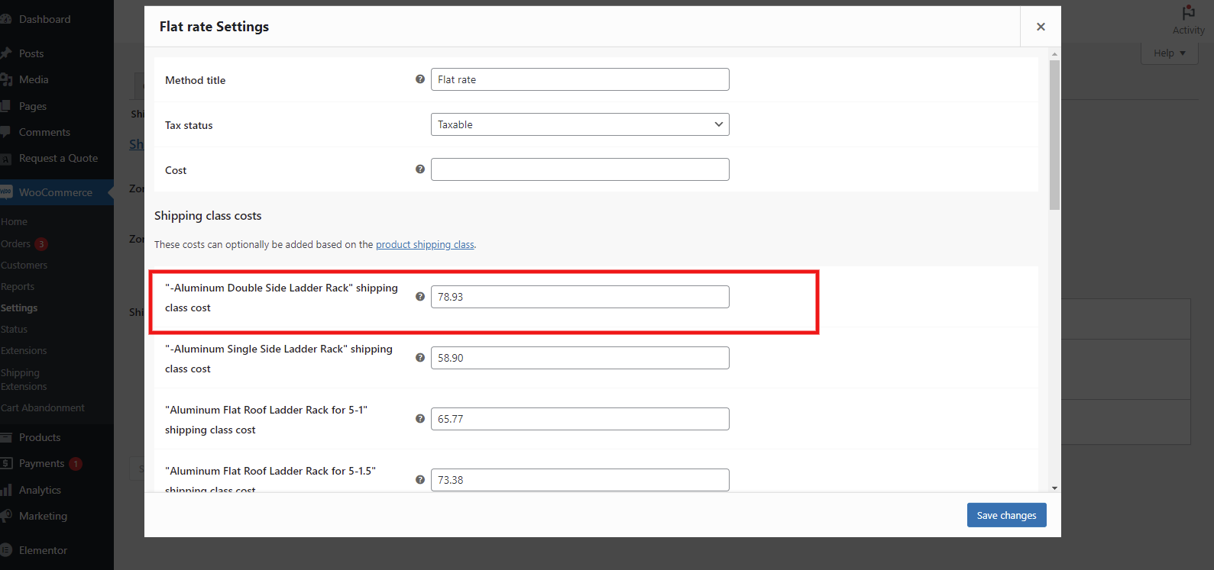

Product Variations: If the product has variations, each variation's shipping settings might need to be adjusted to ensure the flat rate is calculated correctly.

4. Conclusion
In conclusion, the case study highlighted the challenges faced by an e-commerce website when the Flat rate shipping rate is not displayed correctly for specific products. Through a systematic investigation and troubleshooting process, the root causes of the issue were identified and resolved, leading to a successful outcome.

